19
Site Plan - Rafting Momentum
doris Rush-Lopez
cit 230 – section 14 – MICHAEL ODOM – BYU-IDAHO – WINTER 2020

Overview

Site Purpose

Rafting Momentum is an earth aware company that serves the needs of those who are also earth aware and desire to enjoy nature on the rivers, but don’t have the knowledge or equipment to do so.
There are two main reasons for the existence of Rafting Momentum’s website. First, we wish to increase visitors’ awareness of the earth’s treasures and how to preserve them. Second, we need to increment traffic on the website as well as the number of conversions, resulting in an upswing in package bookings to increase income.
We will accomplish these goals through gaining the attention of our audience by using a bold call-to-action on the home page. This will encourage site users to learn about guarding the environment for future generations.
By providing free education content on the site, we will promote the connection between our nature voyages and the environment, thus earning their trust.
Our inviting, responsive pages will entice users on any type of device to fulfill their weekend or vacation dreams.

Target Audience

Our target audience is healthy, active adults of any age, marital status or gender. They may or may not have children, but we have a minimum age of 8, for the family tour packages only.
They have a high level of education, and thereby strong financial power and habits of purchasing what they want, regardless of the cost.
These individuals and families live in cities and work indoors, thus the preference for outdoor late spring, summer and early fall weekend and vacation activities. Some desire to push their physical limits, others just wish to spend time communing with nature.
They are invested in protecting the earth’s resources and to teach this principle to their children. They have a desire for repeated experiences to make memories for the rest of their lives, especially for their children.
Our audience will be looking for information mainly on mobile devices, especially smart phones, but also on laptop and desktop computers.

Branding

Website Logo

Color Palette
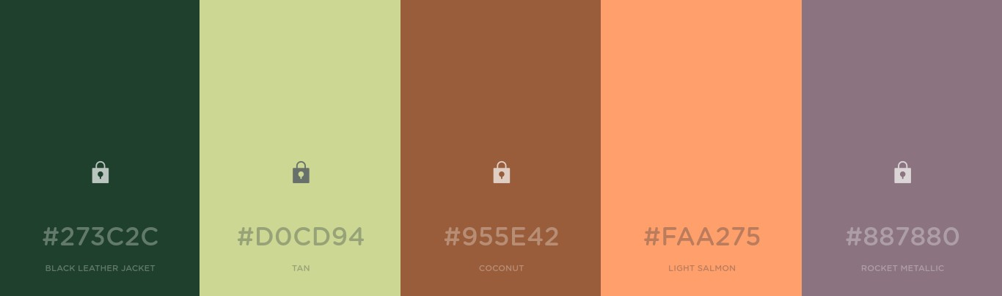

Primary Color | Secondary | Accent | Accent | Accent
#273C2C  (BLACK LEATHER JACKET) | #D0CD94  (TAN) | #afe1fa  (COCONUT) | #d6aa42  (LIGHT SALMON) | #2c6c7c  (ROCKET METALLIC)

Typography
Headline Font
Calligraffiti

Reasoning
This font is read easily and has an attention-grabbing look which is perfect for headlines for this sassy, adventurous company/website.

Body Text Font
Sriracha
Reasoning
Using Sriracha for body text will give continuity with the lower level headlines and easy readability to the page content. This spicy font also gives more sassiness and adventure to the site.
Samples
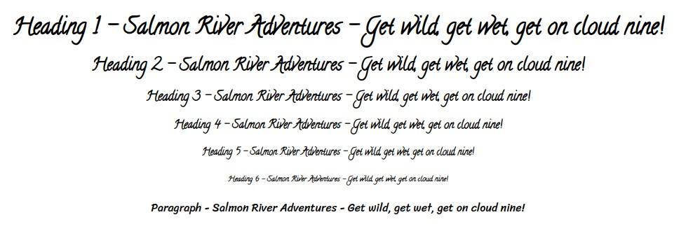

Navigation

Main Navigation Links
Main page: Experience the Momentum, Subpages: Guarding the Environment and Fulfill Your Dreams

Normal Link Color(s): text: #d6aa42 (gold metallic), background: #274a69 (deep koamaru)
Hover Link Color(s): text: #afe1fa (blue lagoon), background: #274a69 (deep koamaru)
Active Page Link Color(s): text: #274a69 (deep koamaru), background: #d6aa42 (gold metallic)

HTML Links

Normal Link Color: #d6aa42 (gold metallic)
Hover Link Color: #767676 (sonic silver)
Visited Link Color: #274a69 (deep koamaru)

Layout

Site Map

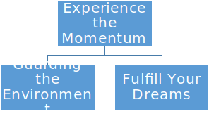

Wireframes
Insert screen shots of your wireframes. (The home page wireframe has been provided for you and already inserted. You will insert your sub-page wireframes toward the end of the term.)
Home Page
